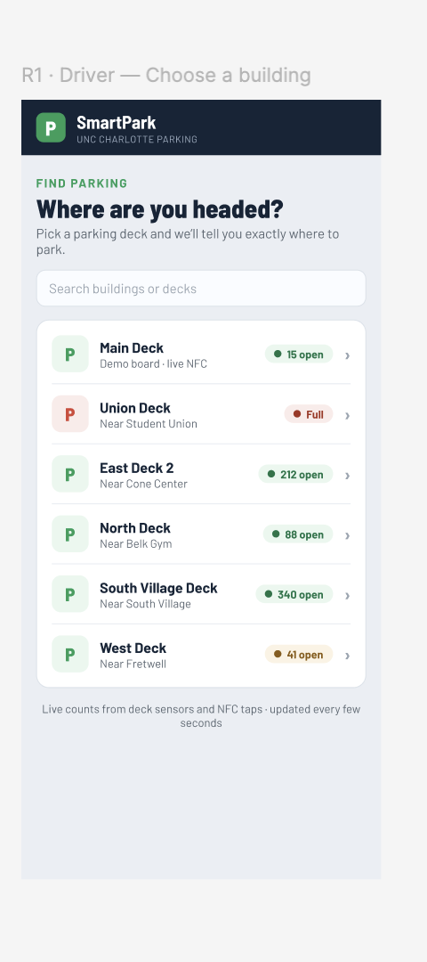
Step 1: When the user opens the app, it lists all decks with available spots.

- App lists all parking decks on campus with available spaces
- A search bar helps you look for the desired building you need to go to. The app automatically populates nearby decks with vacancy.

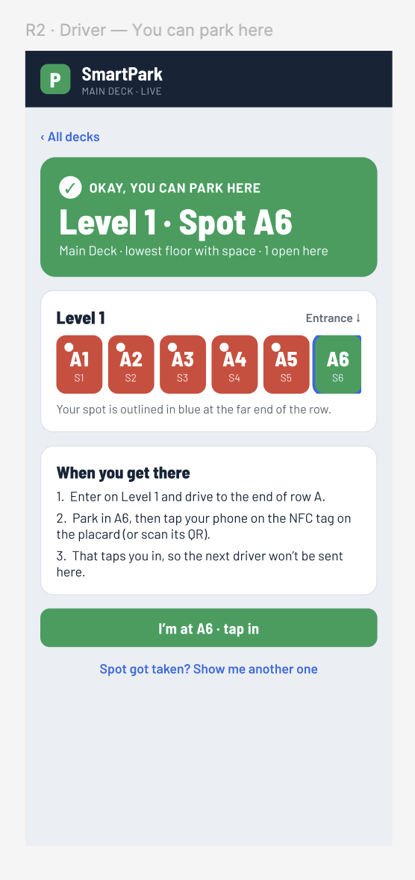
Step 2: User select a deck, and finds vacancy

- If the user selects a deck, the app populates vacant spots and tells users exactly which spot is available, and on which floor.
- The app also shares directions on what needs to be done, once the user gets there and is parked.
- Taken spots are red, available spots are green.

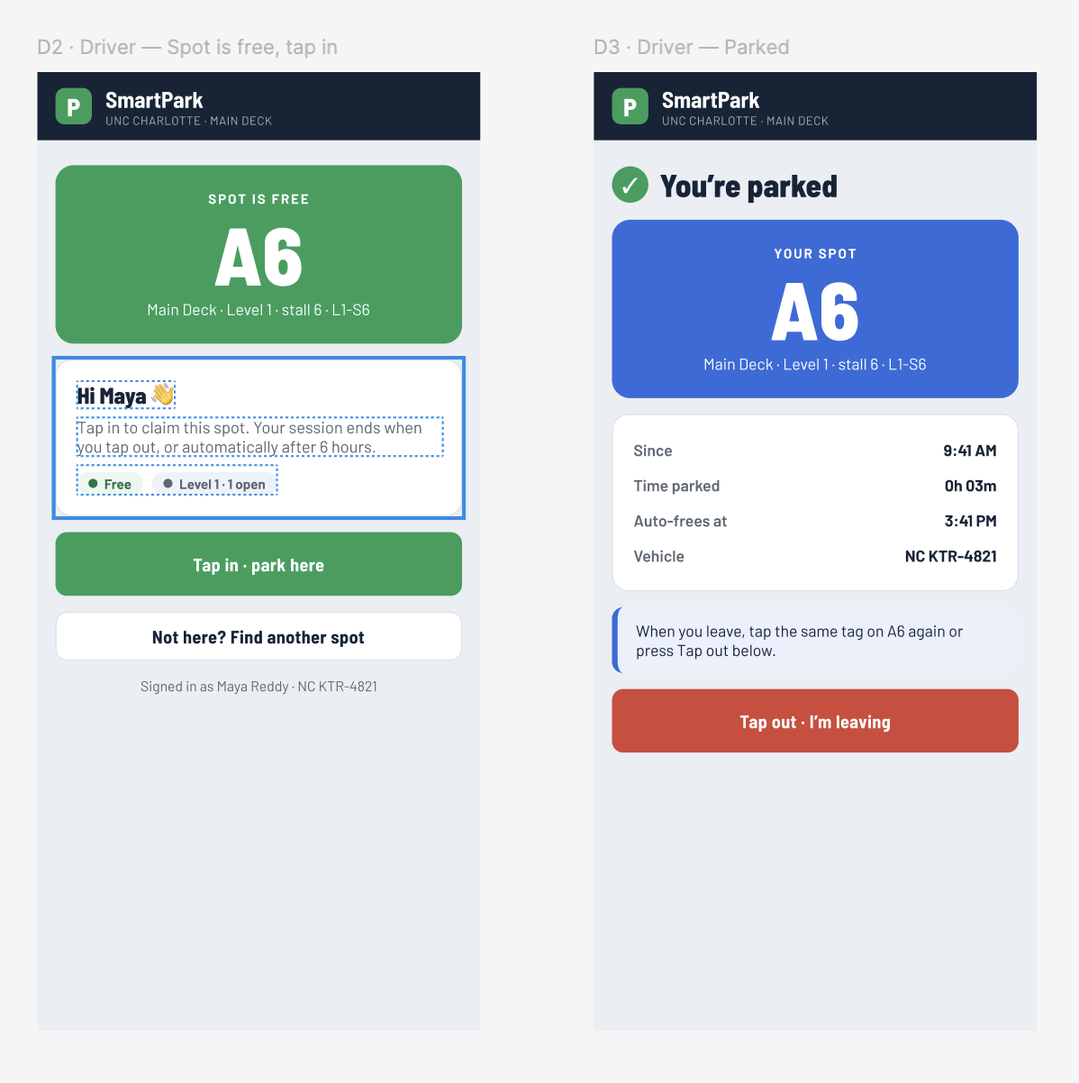
Step 3: User drives to the available spot, everything goes right, spot is still empty by the time he arrives

- User decides to park at Main Deck, level 1 A6
- The user drives to the desired spot. Users can tap into the park.
- Once user leaves, they have to tap out

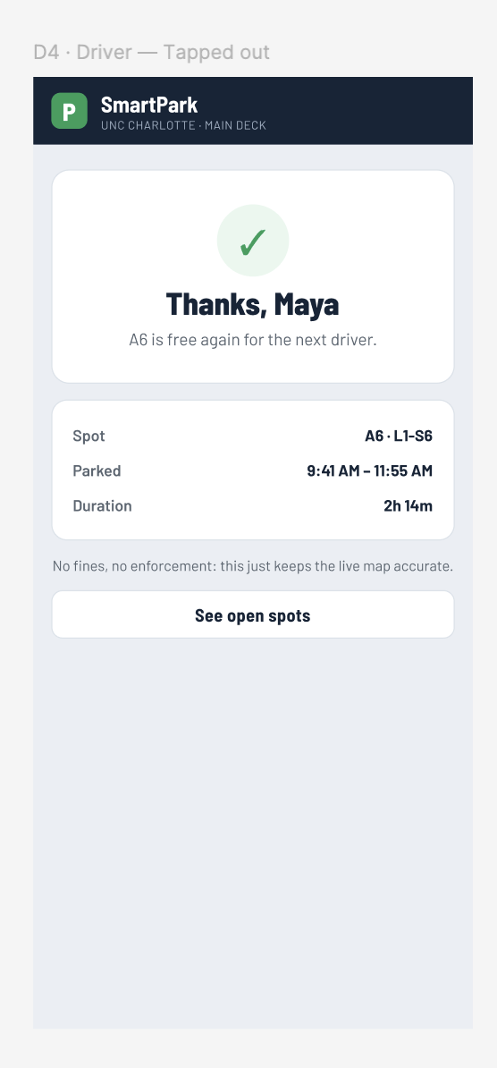
Step 4: User taps out, app generates a summary of its parking

- After user taps out, the app shows the duration they parked there for, and shows that available spot is free now

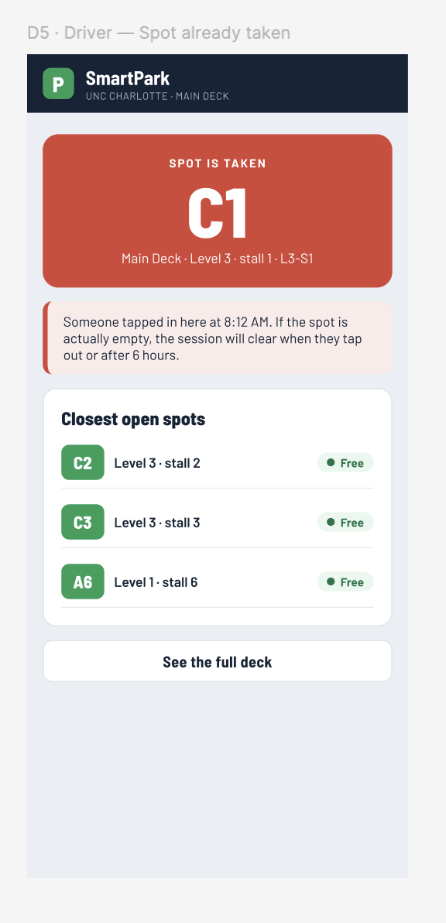
Step 5/ Alternate Condition : Available spot is taken by the time the user gets there
- If a user selects a deck and a spot, and the spot is taken by the time the user drives there. App will populate other available spots in the same deck for the user to park

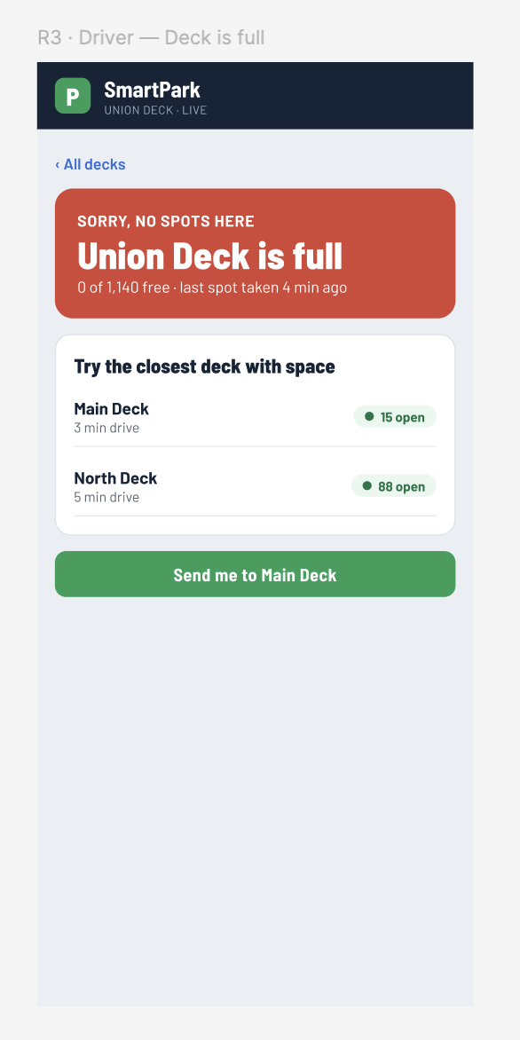
Step 6/ Alternate Condition: The deck gets full by the time user gets there
- If the selected deck is already out of space, the app provides the best available nearby parking deck.
- User will have the flexibility to choose his desired parking deck based on populated decks
- User can select best available opinion and navigate to a free parking spot at the selected deck

